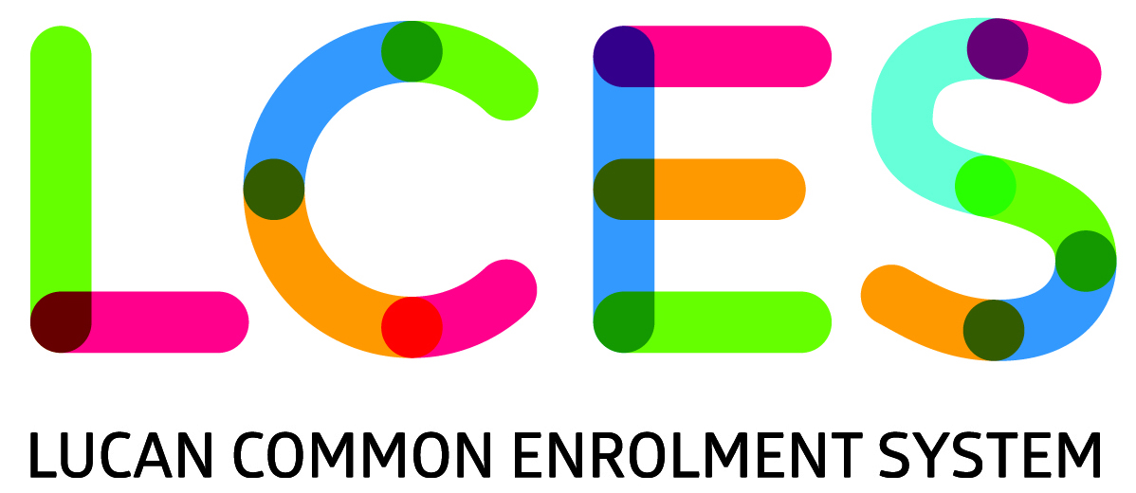

**FOR IMMEDIATE RELEASE: -September-2015**

**Launch of the Lucan Common Enrolment System (Educate Together) October 1st 2015 at 11:00 am**

Four Educate Together national schools in Lucan have come together in an effort to improve, systematically, the way pupils are enrolled in their schools.

From October 1st, Adamstown Castle ETNS, Esker ETNS, Griffeen Valley ETNS and Lucan East ETNS will operate a coordinated admissions system: the Lucan Common Enrolment System (LCES).

The aim of this common enrolment system is to promote inclusive, integrated schools that serve the needs of local families. Essentially, children in Lucan will be able to access their most conveniently located Educate Together school on a fair, transparent and equal basis. The LCES aims to end the situation in which children are forced to crisscross all over Lucan to attend a school that is not necessarily their nearest one.

By default, current enrolment policies are creating segregation in the school system, most notably in rapidly developing urban areas. The Lucan Common Enrolment System aims to address this by levelling the playing field and giving every child equality of access to the most conveniently located Educate Together school in Lucan.

Under the new system, which prioritises students based on age, newcomer families will no longer be disproportionally disadvantaged in accessing schools. Prioritising siblings and proximity to school will help foster local friendships and contribute towards a greater sense of community in the school.

The official launch of the LCES takes place in **Finnstown Castle Hotel, Lucan, on October 1st 2015 at 11:00 am.** Members of the school communities will outline the rationale and the mechanism of the new system at this launch.

**How does the LCES work?**

Parents will make an application to a centralised system, which will be run by a committee of representatives from the Boards of Management of each of the four schools. Children on the system will be assigned to one of the four schools based on specific criteria:

* ***Age:*** The system prioritises children according to their age, with older children given priority over younger children.
* ***Family:*** Siblings will be prioritised so that it will be much more likely that children from the same family will be educated together in one school.
* ***Proximity to school:*** Children will be more likely to be assigned to their **nearest** participating Educate Together school in Lucan.

All names received will be placed on the LCES Database, run by an independent database company. Children on the list will be offered a place in order of age (oldest first), until all available places in the four schools are filled. Once a child has secured a place, the LCES will determine the school to which the child will be assigned. The placement of children in individual schools will be based on the agreed criteria of siblings and proximity.

This is the first time that a common enrolment system has been used by Educate Together schools and we are hoping to get much local and even national publicity, for this new way forward in enrolment, especially in the light of recent publicity around inclusion of migrant families and admissions policies in general. This common enrolment initiative is strongly supported by the Educate Together National Office.

**For more information or to arrange interviews, contact:**

**Colette Kavanagh**

Principal, Esker ETNS

Email: [colette@eskeretns.ie](mailto:colette@eskeretns.ie)

Phone: 01 6241462 or 0860261060

**Meena Baskarasubramanian**

Parent and Chairperson BOM, Adamstown Castle ETNS

Email: [meenaolag@yahoo.com](mailto:meenaolag@yahoo.com)

Phone: 086 8936001